- First you need to install docker using below url
- https://docs.docker.com/desktop/install/windows-install/
- Because minikube container requires docker to be installed in the machine
- But add the docker to environment variable and then install minikube using below url
- 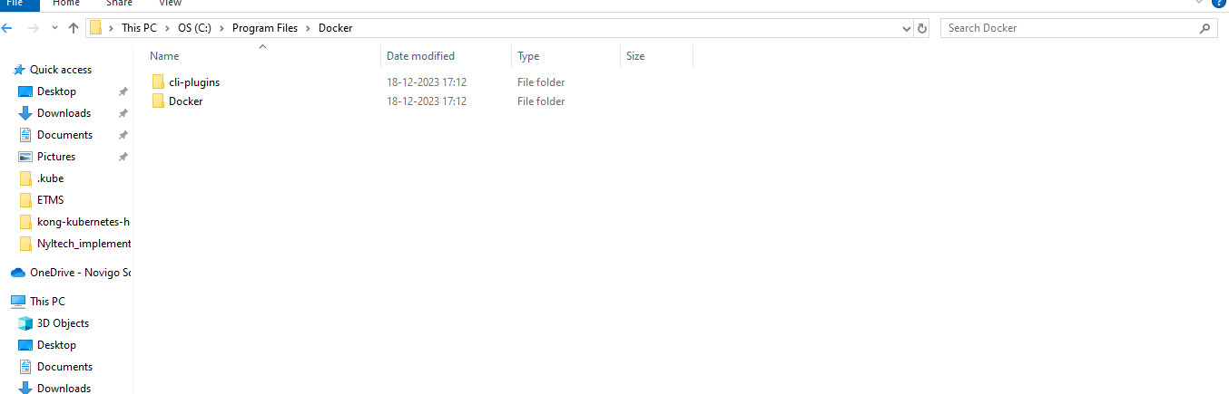
- Link for minikube installation
- https://minikube.sigs.k8s.io/docs/start/
- 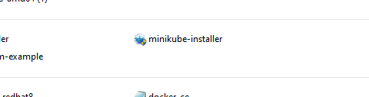
- Install the installer in the machine
- Then add path which is given in installer in the environment variable
- Then u need run the docker desktop
- Then run minikube start
- This will by default adds kubectl
- No need separately install kubectl

Where we can see config file or cluster file of minkikube it is available in the below image space
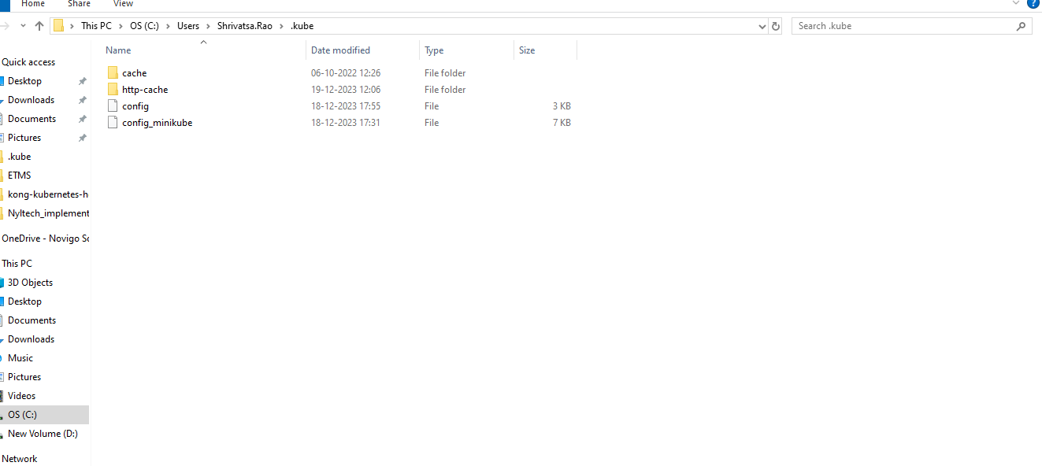
- Here this is cluster file
- Initially it was only config when it was running locally, to run any cluster locally here in this path you need to add your config file then only it works.
- I have taken the config file given by nyltech cluster and then that config file you need to name as only “config” then save it.
- If your others files in this directory then you need to rename to whatever files other names such now I have config file of nyltech and I want to use nyletch locally hence I have kept the name of nyltech cluster as config and I renamed the minikube cluster as config_minikube.
- Then u need to check the context which ur deploying the elements and the server context are same .
- So these are some important points for setting the cluster locally.

If u have deleted some namepscaes in cluster and when you do kubectl get ns u will see some of the namepsaces in terminating state that won’t get deleted for many days hence you need to follow below steps.
- 1) If the namespace still in “Terminating” state or you couldn’t revolve the API resource issue, you can try to force delete the namespace.
- Dump the contents of the namespace into to a temp JSON file
- kubectl get namespace <terminating-namespace> -o json > tmp.json
- 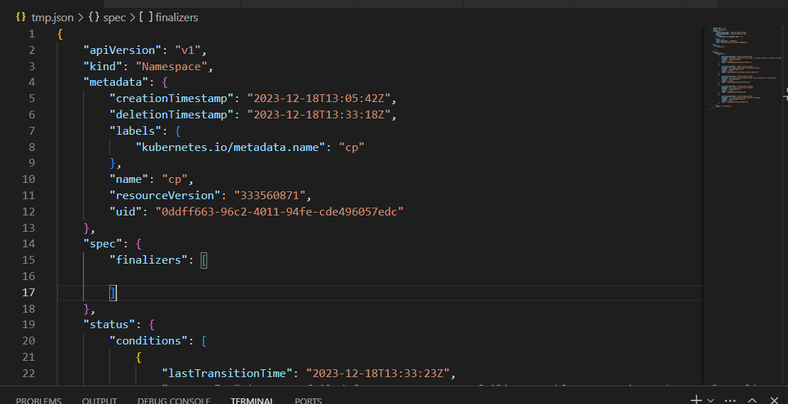
- 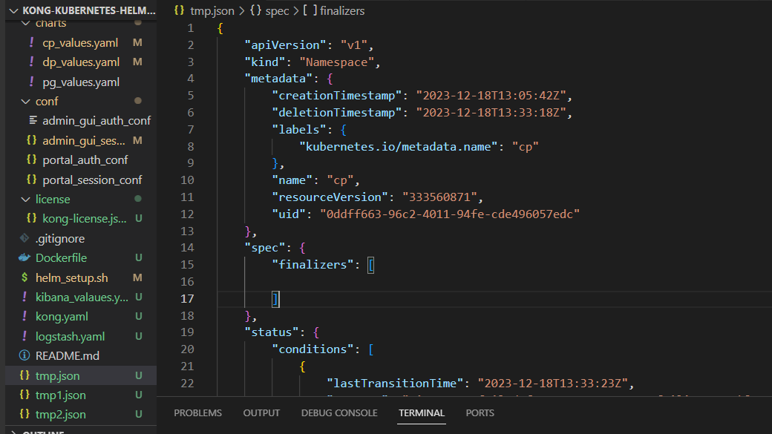

- 2) Edit your tmp.json file. Remove the kubernetes value from the finalizers field and save the file.

- 3) Set a temporary proxy IP and port, be sure to keep your terminal window open until you delete the stuck namespace:
- 4) In the separate window you need to open the and run the command as kubectl proxy.
- kubectl proxy
- 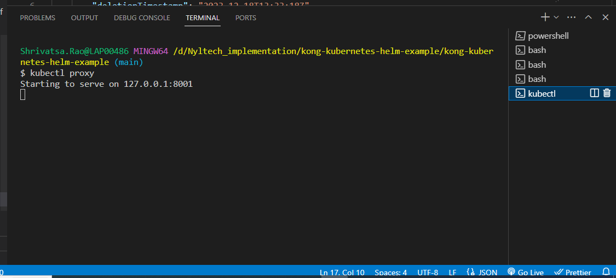

- 4) Open a new terminal windows, run the following command:
- >>> curl -k -H "Content-Type: application/json" -X PUT --data-binary @tmp.json http://127.0.0.1:8001/api/v1/namespaces/<namespace>/finalize
- 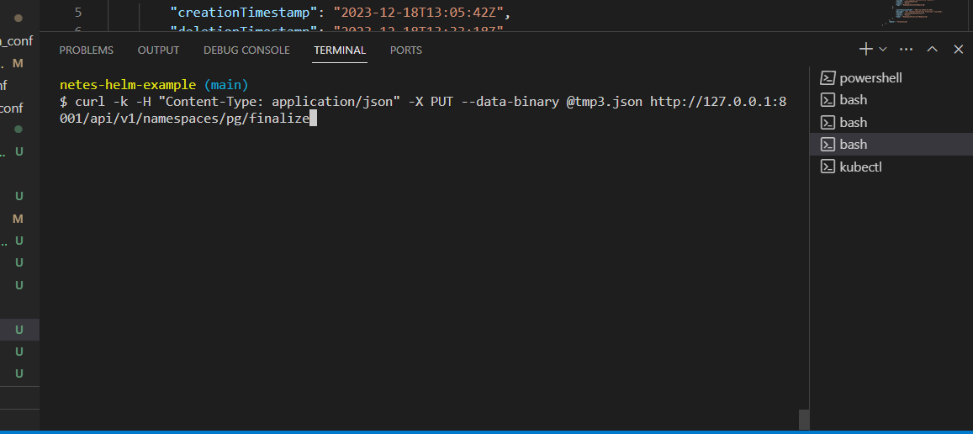

The above command u need run in separate terminal and proxy also should be running..
- 5) Verify that the terminating namespace is removed:
- >>> kubectl get namespaces
- referred from:
- https://blog.devgenius.io/k8s-troubleshooting-namespace-stuck-in-terminating-state-b91ab6fa8948

